Michigan/Indiana St. Joseph River Watershed Conservation Partnership
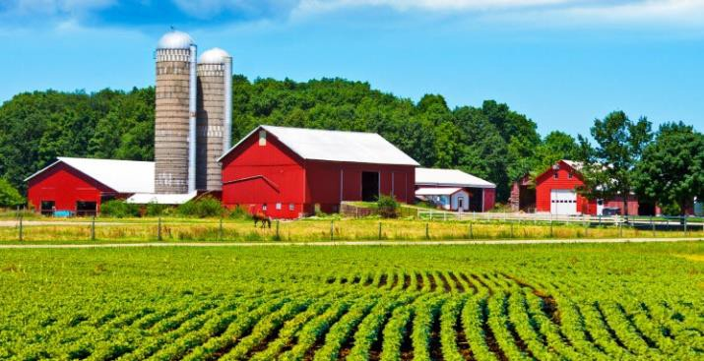
Regional Conservation Partnership Program - RCPP

The St. Joseph River Watershed Conservation Partnership is a bi-state project to improve and protect the streams, rivers, lakes and groundwater in the St. Joseph River Watershed. The project aims to reduce sediment and nutrient loading, optimize groundwater use and enhance fish and wildlife habitat. Project partners have selected Natural Resource Conservation Service (NRCS) conservation practices that farmers can receive financial assistance to implement. These practices improve soil health and water quality and enhance fish and wildlife habitat.
$6.8 million in Farm Bill funds were dedicated to this project to provide technical assistance to landowners and to implement practices and wetland restorations through the Wetland Reserve Easement program (WRE).
Eligible Applicants:
Agricultural producers who are in the St. Joseph River Watershed are eligible to apply.

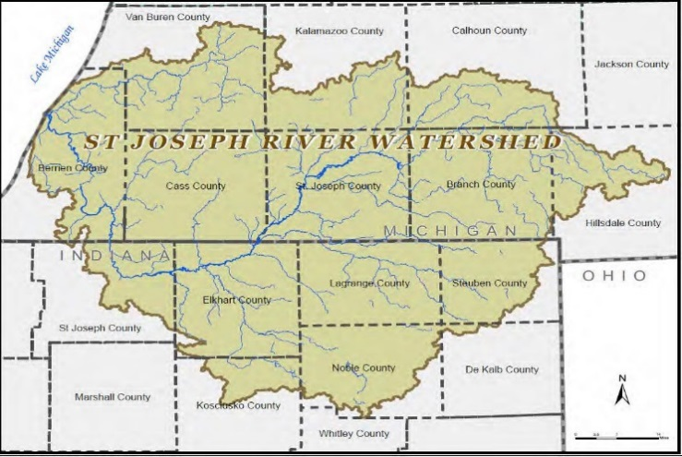
Interested or Have Questions?
Please contact the NRCS Office or the <County> Conservation District in <Location> at <Phone Number> with any questions. We will get you started with meeting program eligibility through the Farm Service Agency, assist with the development of a farm conservation plan through NRCS, and apply for desired practices through EQIP or WRE.
Expected Outcomes:
Clean and Abundant Water
- - Reduced sediment and nutrients
Better Habitat
- Restored wetlands
- Improved fisheries
- Increased pheasant/turkey/waterfowl populations
Profitable and Productive Farms
Program Objectives:
The St. Joseph River Watershed Conservation Partnership will help to:

- Reduce sediment and nutrient loading
- Optimize groundwater use
- Enhance fish and wildlife habitat
Wetland Reserve Easements – Through the Agricultural Conservation Easement Program, landowners receive assistance to restore wetlands that were converted to agricultural use. The USDA purchases a permanent or a 30-year easement on the land to ensure that the restored wetland is preserved.
Conservation Activity Plans:
Comprehensive Nutrient Management Plan: Develop a livestock waste management plan.
Conservation Plan Supporting Organic Transition: Develop a transition plan from a conventional farming or ranching system to an organic production system.
Drainage Water Management Plan: Develop a plan to control soil water table elevations and discharges from subsurface agriculture drainage systems.
Fish and Wildlife Habitat Management Plan: Develop a site specific plan for fish and wildlife habitat.
Integrated Pest Management Plan: Develop an ecosystem-based plan to manage pests using a combination of techniques.
Irrigation Water Management Plan: Develop a plan to control the volume, frequency, and rate of water for efficient irrigation.
Nutrient Management Plan: Develop a nutrient management plan for fertilizers.
Priority Core Practices:
Access Control: Install a temporary or permanent barrier to exclude animals, humans, vehicles, and/or equipment from an area.
Amending Soil Properties with Gypsum: Improve soil physical/chemical properties to reduce soil erosion and improve infiltration.
Conservation Cover: Plant species to reduce erosion and protect water quality.
Cover Crop: Plant 1-3 species for soil health and water quality management.
Critical Area Planting: Plant permanent vegetation on highly disturbed sites with high erosion rates.
Drainage Water Management: Install a drainage water control structure, and manage it for water quality.
Field Border: Plant a strip of permanent vegetation at the field edge or around field perimeter.
Filter Strip: Plant species that increase water infiltration and protect water quality.
Grassed Waterway: Provide means for slowing water flow and increasing infiltration.
Irrigation System, Sprinkler: Install the necessary equipment and facilities for efficient water application.
Irrigation Water Management: Implement irrigation management to optimize for the most efficient use of water.
Nutrient Management: Implement Nutrient Management Plans for nutrients and sediment.
Open Channel: Construct, improve, or restore an open channel to convey water.
Prescribed Grazing: Manage the harvest of vegetation with grazing and/or browsing animals.
Residue and Tillage Management – No-Till: Implement modified tillage and residue management to increase water infiltration.
Residue and Tillage Management – Reduced Till: Implement reduced tillage methods and manage plant residue distribution on the soil surface year round.
Restoration and Management of Rare and Declining Habitats: Restore habitat for rare and declining wildlife species.
Riparian Forest Buffer: Plant tree and/or shrubs adjacent to a watercourse or water bodies.
Riparian Herbaceous Cover: Plant grass or forbs tolerant of intermittent flooding or saturated soils for terrestrial or aquatic habitat.
Stream Crossing: Construct a travel way for people, livestock, equipment, or vehicles across a stream.
Stream Habitat Improvement and Management: To maintain, improve, or restore the functions of a stream.
Streambank and Shoreline Protection: Install treatments to stabilize/protect stream banks, construct channels, and shoreline of lake, reservoirs, or estuaries.
Supporting Practices:
Channel Bed Stabilization: Stabilize the channel bed or bottom.
Fence: Construct a barrier for animals or humans.
Forage and Biomass Planting: Plant a grass species suitable for pasture, hay, or biomass production.
Heavy Use Area Protection: Stabilize a ground surface frequently and intensively used by people, animals or vehicles.
Livestock Pipeline: Install a pipeline to move water for livestock.
Spoil Spreading: Dispose of surplus excavated materials.
Trails and Walkways: Construct a walkway used by animals, people, or off-road vehicles.
Subsurface Drain: Install tile beneath the ground surface to collect and/or remove excess water.
Watering Facility: Install a permanent or portable device to provide drinking water for livestock.

USDA is an equal opportunity employer, provider, and lender.

